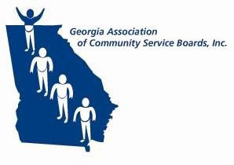
GACSB
Administrative Operations Committee Thursday, October 9, 2025
10:00 a.m.

Join Zoom Meeting

https://bhsga.zoom.us/j/81655903895?pwd=4Iisdc1n6nMraQc0AfRbEKSNgRrEiP.1
Meeting ID: 816 5590 3895
Passcode: 747877

- Welcome/Call to Order Pam Cartwright

- Approve 10/9/2025 Agenda Pam Cartwright

- Approve 9/11/2025 Minutes Pam Cartwright
- Focus Group Reports Focus Group Leads
  - HR/Compliance -Laura Fullard
  - IT-Fabio van der Merwe
  - CFO-Lee Pavlik
  - Revenue Cycle- Angela Holt

- Strategic Plan Initiatives Update GACSB Executive Office
  - Strategic Priorities 1-4

- State-wide Policy Initiatives GACSB Executive Office
  - CCBHC Updates
  - DBHDD Updates
  - GACSB Updates
    - 2025 GACSB Educational Exchange

- Other Pam Cartwright
- Disaster Preparedness/Continuity of Operations Plan
- Renter’s Insurance Discussion

- Next Meeting Pam Cartwright
  - Thursday, November 13, 2025
  - 10:00am
  - Zoom

- Adjournment Pam Cartwright

